Gender, Sharia, and Public Sphere: Women Navigating Qanun in Aceh’s Coffee Shop Culture

Khori Suci Maifianti¹, Sarwititi Sarwoprasodjo², Rilus A Kinseng³, Dwi Sadono⁴, Sarah P Cardey⁵
¹Universitas Teuku Umar, Aceh 23681, Indonesia
²³⁴ IPB University, Bogor, 16680, Indonesia.
⁵ University of Reading, UK

Article Information |  | ABSTRACT
Received: July 02, 2025  Revised: December 27, 2025  Available online: January 30, 2026 |  | This study aims to examine how women in Aceh navigate Sharia-based moral regulations within the gendered public sphere of coffee shop culture and to analyze the strategies they employ to construct agency, identity, and visibility under Qanun governance. Using a descriptive phenomenological approach, this research adopts Judith Butler’s theory of gender performativity as its main analytical framework. Data were collected through semi-structured interviews and participant observation involving five active female informants in coffee shops in West Aceh. The findings indicate that women’s participation in coffee shop culture represents adaptive and strategic forms of everyday agency. Women negotiate religious and social boundaries by regulating their presence through specific choices of visiting time, clothing, seating positions, and interaction styles, allowing them to remain within socially acceptable norms while subtly challenging gendered exclusions. Furthermore, coffee shops function as informal yet significant arenas for gender contestation, enabling women to build professional networks, engage in public discourse, and consolidate social and professional agendas in traditionally male-dominated spaces. In conclusion, the study demonstrates that the public sphere in Aceh simultaneously reflects Sharia control and opens opportunities for women to exercise adaptive and subversive agency. These findings contribute to the literature on gender relations, Sharia regulation, and public space by highlighting coffee shops as micro-level sites where women continuously negotiate identity, rights, and participation in a post-conflict society governed by religious norms.
Keywords
Gender public sphere; Qanun Aceh; Coffee shops; Women’s civic participation
Correspondence
Name: Khori Suci Maifianti
Email: khorism@utu.ac.id

INTRODUCTION
Aceh is the only province in Indonesia granted special autonomy to implement Islamic Sharia through regional regulations known as Qanun. These regulations not only establish a legal framework but also shape the social and cultural landscape of community life, including gender relations in public spaces (Manan & Salasiyah, 2022; Shadiqin & Srimulyani, 2022). Although the Qanun on the Empowerment and Protection of Women formally aims to uphold women's rights, its implementation has created a paradox. On the one hand, it seeks to uphold women's dignity; on the other, it has created a series of moral regulations that restrict women's mobility, dress, and social interactions (Bahri, 2022; Zulkifli et al., 2022). This paradox demonstrates that Sharia-based moral governance can be an ambivalent arena—providing space for empowerment while simultaneously asserting control over women's bodies and behavior.
In this context, coffee shops (warkop) in Aceh occupy a unique position as public spaces imbued with both social and symbolic meaning (Maspul, 2023; Xu et al., 2024). Historically, warkop have been male-dominated venues for socio-political discussion. However, in recent years, women's presence in these spaces has become increasingly visible, giving rise to new dynamics in gender relations. Their presence is not merely a recreational activity but also a strategy for negotiating identity and a form of symbolic expression within patriarchal expectations and religious norms (Jalil et al., 2022). Through the perspective of gender performativity, women's presence in warungs can be understood as a bodily practice that negotiates agency and visibility within a space framed by moral and religious rules (Johnson, P. M., 2019; Wijanarko, M. F., & Madaniyyah, F., 2025).
Although numerous studies have been conducted on women, Sharia, and public space in Aceh, most research focuses on institutional, domestic, or formal policy domains (Manan & Salasiyah, 2022; Bahri, 2022). These studies tend to highlight how women are regulated and represented, but they do little to explain how women act, negotiate, and reinterpret these norms in everyday practice. Studies of women's agency under Sharia-based legal regimes rarely use informal public spaces like coffee shops (warkop). This gap indicates an empirical and theoretical gap in understanding the forms of women's negotiation of moral governance and public space in Aceh.
The VOSviewer results indicate that studies linking feminism and regulations governing women in public spaces, particularly how policies, social norms, and women's rights are regulated and experienced within the context of public spaces, represent a potential area for further research. Based on this gap, this study is designed to investigate how women in West Aceh navigate Sharia regulations and patriarchal norms through their participation in coffee shop culture. By positioning women's activities in coffee shops as a form of everyday gender negotiation, this research offers a new analytical perspective that links Sharia-based governance to theories of spatial justice and gender performativity. The primary research question is: How do women in Aceh negotiate Sharia-based moral and religious boundaries through everyday practices in coffee shop culture, and what performative strategies do they use to construct identity and visibility within a gender-regulated public sphere?
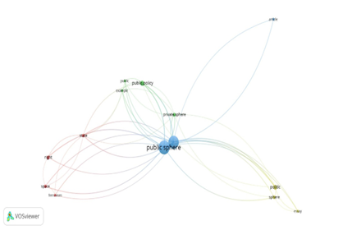
The originality of this research resides in its emphasis on quotidian practices and informal public spaces—elements seldom examined in the literature concerning gender and Islam in Aceh. Unlike previous studies that emphasize legal or institutional dimensions, this research reveals how women's everyday spatial practices constitute subtle forms of resistance and attempts to redefine gender boundaries under Sharia law.
Academically, this research contributes to the development of studies on gender, public space, and Islam by expanding the concept of gender performativity within the context of societies governed by religious law. The practical implications of this research are anticipated to inform the development of more gender-sensitive policies and enhance comparative discussions regarding women's agency in Muslim societies, specifically in Indonesia and other areas, including Malaysia and the Middle East (Firouzabadi et al., 2024).

METHOD
This study uses a qualitative, descriptive, phenomenological approach to capture the lived experiences of women in informal public spaces (coffee shops) in West Aceh. This study explores how they negotiate gender identity within the context of Sharia regulations. The phenomenological approach was chosen to capture the subjective meaning of everyday experiences that cannot be explained solely through quantitative data (Bush et al., 2019; Carel, 2011; de Boer & Zeiler, 2024).
This study uses primary and secondary data. Primary data was obtained through semi-structured interviews and participant observation. Secondary data was obtained from supporting documents, academic literature, and policy reports related to the Qanun.Informant Selection Informants were selected purposively based on their active involvement in coffee shop activities. Five female informants, aged 25–45, were selected from diverse occupational backgrounds (civil servants, academics, NGO activists, students, and journalists). This diverse background was intended to represent intersectional experiences in terms of class, religion, and social expectations.
The data collection techniques used in this study were as follows:
- Semi-structured interviews: used to explore personal experiences, negotiation strategies, and informants' perceptions of social norms.
- Participant observation: conducted in several coffee shops in West Aceh to record interactions, visit duration, and forms of women's participation.
- Documentation: supplemented the data with written sources such as reports, articles, and related Qanuns.
Data were analyzed using an interpretive phenomenological approach in three stages:
- Transcription and initial coding,
- Thematic categorization based on indicators of gender behavior (see Table 1),
- Interpretation with an integration of Judith Butler's theory of gender performativity and feminist ethnography.

This analysis aimed to uncover the meaning of women's experiences in negotiating public space.
Table 1. Analytical Categories, Indicators, and Data Sources in the Study of Women’s Participation in Coffee Shops
Category | Indicators | Derived from
Visit Frequency | Rare / Moderate / Frequent visits per week | Interview transcripts
Duration at Coffee Shop | Short (<1 hour), Medium (1–2 hrs), Long (>2 hrs) | Observation logs
Dominance in Discussion | Leading, Participating, Passive in group conversations | Interview + Observation
Nature of Activities | Socializing, Professional Meetings, Study, Relaxation | Interview + Field Notes
Role Subversion | Attending alone, Hosting meetings, Speaking publicly | Interview Narratives
Norm Negotiation | Time restrictions, seating position, tone moderation | Field observations
Cultural Integration | Participation accepted, women making decisions, cultural acceptance of presence | Combined methods

Table 1 outlines the core analytical categories used to interpret gendered behavior in Aceh’s coffee shop settings, detailing the specific indicators for each category and the qualitative sources from which they were derived. These categories guided the coding and interpretation of field data, providing a structured framework to assess how women negotiate visibility, agency, and social acceptance within Qanun-regulated public spaces.

Data Collection:
Observations and Semi-structured Interviews
Data Processing
Data Analysis
Triangulation/Validation
Figure 1. Research Method Flowchart

RESULTS AND DISCUSSION
In Habermas’s (Habermas, 1991) framework, the public sphere refers to a communicative arena where citizens engage in dialogue and deliberation to influence social and moral norms. However, as feminist and postcolonial scholars (Fraser, 1990; Mahmood, 2005; Wadud, 2013) have argued, this sphere is not neutral—it is shaped by exclusionary gender, class, and religious boundaries. In Aceh, the public sphere is both a legal and moral space that is governed by Qanun, which are regional Islamic laws that make Sharia principles part of how people act in public.
Operationally, in this study, public sphere refers to informal public spaces (coffee shops) where gendered interactions and discussions occur under social and legal visibility. Qanun is defined as a set of regional Islamic legal norms that govern moral behavior in public life, particularly related to women’s mobility, attire, and social interaction. These two concepts frame the analysis of how women’s participation in coffee shops becomes a site for negotiating visibility, agency, and religious compliance.
Women’s participation in such spaces thus embodies what Habermas termed communicative action—an everyday form of dialogue that contributes to constructing meaning and moral legitimacy. Nevertheless, under Islamic feminist perspectives (Mahmood, 2005; Wadud, 2013), women’s agency is not necessarily oppositional; it is exercised through embodied piety, strategic conformity, and subtle reinterpretation of religious norms. Hence, Acehnese women’s presence in coffee shops represents a hybrid form of pious deliberation—where religious observance and civic participation intersect.
The findings reveal complex dynamics through four major themes: (1) gender visibility and performativity, (2) negotiation of social and religious norms, (3) gender contestation and subversion, and (4) synthesis of dimensions of gender participation in coffee shops.

Gender Visibility and Performativity
Women’s presence in coffee shops is not merely social participation but a symbolic act of visibility in a historically masculine public space. Based on Table 1, women exhibit varied patterns of visit frequency and duration—ranging from rare to frequent and short to extended stays—that demonstrate their strategic spatial occupation of public domains.. Informants like Cdy even attend regularly and lead discussions, demonstrating gender performativity (Adisa et al., 2019; Benstead, 2021; Brysk, 2022; Ferry, 2025; Lindkvist, 2024). that challenges patriarchal expectations. This phenomenon aligns with studies in Church (Wood, 2019), Pakistan (Shah, 2024) and China (Qiu, 2023) that found cafes as arenas for women to negotiate the boundaries between tradition and modernity (Firouzabadi et al., 2024).
Acts such as sitting, opening laptops, and leading conversations signify epistemic agency: a capacity to claim intellectual and moral voice. These behaviors reflect gender performativity (Butler, 1990), where repetition of everyday gestures constructs identity and challenges patriarchal expectations.
Through Butler’s (Butler, 1990) notion of gender performativity, women’s daily practices reproduce gendered expectations while simultaneously redefining them. In Aceh’s context, these actions also embody Mahmood’s (Mahmood, 2005) concept of pious agency, where women’s compliance with Sharia norms—modesty, time discipline, and moral conduct—becomes a tool for self-expression within religious boundaries.
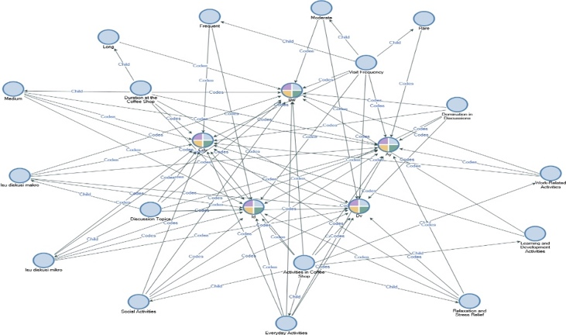
Figure 2. Gender Performance Coding Map of Women’s Participation in Coffee Shops
This visual map illustrates the relationships among codes and categories derived from qualitative analysis, showing how gender performance, through activity type, frequency, duration, and discussion engagement—is interconnected across all informants.
Figure 2 illustrates the complex network of categories and codes derived from the thematic analysis of women’s gender performance in coffee shops in West Aceh. The figure shows how four main categories Duration at the Coffee Shop, Visit Frequency, Domination in Discussions, and Activities in Coffee Shop interconnect with subcategories such as “Work-Related Activities,” “Social Activities,” “Learning and Development,” and “Relaxation and Stress Relief” ((Bahri, 2022; Zulkifli et al., 2022). Each node in the map represents a theme or subtheme, while the connecting lines indicate interrelationships based on overlapping references across informants. The density and centrality of nodes such as “Discussion Topics” and “Domination in Discussions” demonstrate their importance in shaping women’s active roles in public discourse within these spaces (Billah, 2024; Munira et al., 2018).
Notably, the map reveals that gender performance in this context is multidimensional and relational. Informants like Cdy and Id represented through frequent connections to leadership in discussion, macro-issue engagement, and extended duration in the café indicate a strong presence in both intellectual and professional spaces (Inayatillah, 2023; Sufyan et al., 2022). In contrast, other participants like Dv and Bw are more closely linked to relaxation and social activities, showing that even less assertive forms of engagement still contribute to the gradual reshaping of public norms (Zulkifli et al., 2022). The spread of connections across traditionally “private” and “public” coded behaviors suggests that coffee shops have evolved into gendered social arenas where identity, space, and power are continuously negotiated (Standal & Winther, 2016; Sufyan et al., 2022).
Moreover, the figure underscores the performative and adaptive strategies employed by women in navigating Aceh’s socially regulated environment under Qanun (Fransen, 2023; Zulkifli et al., 2022). The nodes related to “Micro-issue Discussion,” “Time Norms,” and “Repetition of Practices” reveal how even within seemingly restrictive settings, women maintain a dynamic presence (Aziz et al., 2023; Kivijärvi & Katila, 2022). By moving fluidly across social, professional, and reflective roles within the café setting, they contribute not only to the normalization of female presence in public life but also to the production of new socio-religious discourses from the bottom up (Latue et al., 2023; Sufyan et al., 2022).This visualization offers empirical insight into the lived complexity of female agency in everyday Acehnese society (Lopes Cardozo & Srimulyani, 2021).
Gender Subversion in Qanun-Related Contexts The concept map of gender subversion illustrates how women in West Aceh adopt both traditional and non-traditional roles when utilizing coffee shops—spaces historically dominated by men and deeply influenced by local Islamic legal frameworks (Qanun). Key categories within this map include “Women Holding Work Meetings,” “Women Lead Discussions,” “Women Spend a Long Time,” “Women Come Alone,” and “Non-Traditional Role Playing”. The interlinked nodes show the complexity of how women assert their presence not only as passive visitors but as leaders, professionals, and community voices engaging in discussions that often touch on sensitive socio-religious topics, including the implications of Qanun on their daily lives.
The matrix reveals that only a few women are consistently comfortable with asserting their agency in ways that challenge normative expectations. Informants like Cdy a local electoral commission leader and activist frequently used coffee shops as a space to conduct political and legal discussions, including debates about the fairness and consistency of Qanun enforcement on women. She is among those who not only attend participation in discussions around the practical implications of Qanun, especially in cases related to gender-based surveillance (khalwat, dress code enforcement, or moral patrols). Although these individuals do not always take on leadership roles, their consistent contribution to public discourse in informal settings indicates a subtle but impactful form of resistance to dominant narratives. Their selective attendance and active engagement reflect a balancing act between respecting religious norms and questioning the societal double standards embedded in the localized interpretation of Sharia (Bahri, 2022; Lofaro & Miller, 2021; Pieczka & Escobar, 2013).
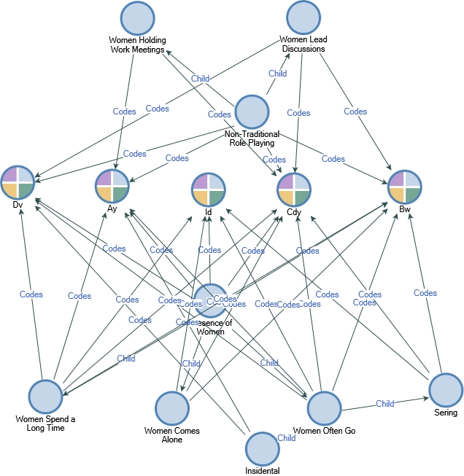
Figure 3. Gender Subversion Coding Map in the Context of Women's Use of Coffee Shops in West Aceh. This concept map visualizes how women adopt non-traditional roles in coffee shop spaces, such as leading discussions, working independently, and navigating public presence under Qanun regulation. The nodes represent key categories and behaviors, while the connecting lines illustrate the interrelations between informants and thematic codes such as “Women Come Alone,” “Women Lead Discussions,” and “Non-Traditional Role-Playing.”
Overall, the data indicate that gender subversion in Acehnese coffee shops is not monolithic but varies by role, frequency, and intent. Women subvert dominant structures not only by leading or hosting discussions but also by creating safe micro-spaces where Qanun can be critically examined (Sabbah-Karkabi, 2024). These acts whether intentional or intuitive—redefine women's roles in the public sphere and offer alternative interpretations of female piety, leadership, and citizenship within a Qanun-governed society (Jiménez-Moya et al., 2022). Figure 3 presents a detailed visual analysis of gender subversion within coffee shops as mapped through qualitative coding. Central to this map is the concept of Consistency of Women’s Presence, which links to various forms of subversive behavior including Women Leading Discussions (Yildirim et al., 2021), Women Holding Work Meetings (Abdallah & Farhan, 2023; Offermann & Foley, 2020), and Non-Traditional Role-Playing (Madsen et al., 2020).
Informants such as Cdy, Ay, and Dv demonstrate high connectivity with these subversive categories, indicating active public engagement that challenges normative gender expectations in Aceh's religiously regulated spaces. Their behaviors such as coming alone, staying for extended durations, and taking leadership in discussion—symbolize an evolving female agency that disrupts the traditionally male-oriented configuration of coffee shops . The visual map also captures gradients of subversion. While Cdy emerges as a central node, linked to both frequent attendance and leadership behavior, Bw and Ay are associated with patterns of strategic presence and professional engagement. In contrast, informants such as Id and Dv show engagement through duration and discussion participation, but with more socially accepted forms of presence.
The relational web of nodes confirms that gender subversion in Aceh is not uniform; rather, it is contingent on positionality, role, and social capital Moreover, the network reveals that the subversion is not overtly oppositional—instead, it is negotiated and embedded within normative frameworks, particularly around acceptable time slots, seating behavior, and discussion topics, including informal critiques of Qanun. Together, the map and its underlying data illustrate how the performance of female identity in Acehnese public life is increasingly hybrid: compliant in form but transgressive in function. Coffee shops, once gendered masculine and policed by moral surveillance, have become arenas of subtle disruption, where women tactically renegotiate their role in society by occupying space, voicing opinions, and making leadership visible—even within the constraints shaped by Islamic law.
Maintaining Norms in the Context of Qanun-Informed Public Behavior This theme refers to how coffee shops in West Aceh serve not only as informal social venues but also as regulatory spaces where traditional norms shaped by religion and local custom—especially those codified in Qanun—are maintained and subtly negotiated. While appearing relaxed and communal, these venues operate within an invisible moral framework deeply influenced by Islamic law. Based on qualitative data, five major categories were identified in how women maintain norms within this setting: Preservation of Social Norms (Insani et al., 2024), Guardian of Community Norms (Black et al., 2013), Reinforcement of Traditional Gender Roles (Tamunomiegbam & Arinze, 2024), Maintenance of Time and Space Norms (Hadaiyatullah et al., 2024), and Mediator of Gradual Social Change (Mashhour, 2005).
The data show that all informants navigated their behavior in ways aligned with socially accepted conduct under Aceh’s Sharia-influenced public expectations. Discussions in coffee shops, although varied in content, tend to remain within safe cultural boundaries. Conversations about Qanun khalwat, dress code enforcement, or moral policing were often framed through personal stories, whispered concerns, or indirect references—never as open resistance. This reflects a behavioral pattern where women balance participation and propriety, carefully choosing words, companions, and times of visit. Most informants reported avoiding night visits and opting for seats in peripheral areas to minimize attention. The presence of such spatial and temporal self-regulation suggests that gender roles are not enforced solely by law enforcement bodies but are actively reinforced through social expectation and peer conformity.
Despite these constraints, the data also illustrate the beginnings of negotiated change. Women such as Ay and Cdy, while upholding visible modesty and behavioral decorum, engaged in recurring discussions about the inconsistencies in Qanun enforcement especially how moral standards are unequally applied to women versus men. These discussions, though measured, contribute to the category of Mediator of Gradual Social Change. Rather than directly confronting established norms, women create small fissures through which alternative perspectives about justice, space, and gender can be discussed. These conversations subtly expand what is permissible to say and do, thus demonstrating that norm maintenance is not static—it is a platform through which incremental, discursively negotiated transformations can occur. Coffee shops, therefore, play a dual role: as protectors of moral conformity and as incubators for a more inclusive discourse on women's roles under Qanun governance.

Negotiating Social and Religious Norms
Women’s navigation of Qanun-based boundaries—through timing, seating, and behavior—illustrates what Fraser (1990) calls subaltern counterpublics: marginalized groups’ strategies to communicate within restrictive moral regimes.
By adhering to visible modesty yet engaging in public conversations, women perform negotiated participation—a balance between religious compliance and discursive agency. This corresponds to Habermas’s idea of communicative rationality, where mutual understanding is achieved through socially constrained but purposeful dialogue.
In Islamic feminist terms, this practice is an act of pious negotiation (Mahmood, 2005): obedience that enables participation, rather than silence. It demonstrates that moral boundaries can be sustained while still allowing women’s visibility and civic involvement.
In practice, women face a dilemma between adherence to Sharia law (e.g., seclusion rules, curfews) and the need to actively participate (Mashhour, 2005). Informants often engage in self-censorship through their choice of clothing (Mashhour, 2005), seating position, or visiting time (Cohen et al., 2024). Figure 3 shows a pattern of normative maintenance, where women prefer to attend during safe hours (morning or afternoon), sit on the sidelines, and avoid expressions deemed "too public."
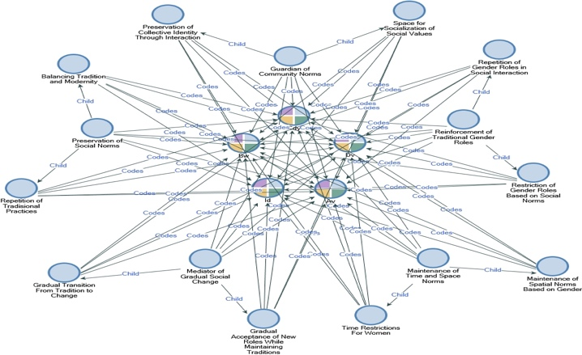
Figure 4. Norm Maintenance and Cultural Boundaries in Women’s Use of Coffee Shops under Qanun.

This diagram captures how women maintain, reproduce, and gradually renegotiate community norms while navigating coffee shop spaces in West Aceh. Nodes represent key normative categories such as spatial boundaries, gender roles, and time regulation, while connections show how these are upheld or adapted by individual informants within the context of Aceh’s Qanun-based moral environment.
Figure 4 illustrates how coffee shops function not only as social gathering points but also as cultural arenas where traditional norms are preserved, especially in relation to women’s behavior under Qanun regulation (Kennedy & Pek, 2023). All five informants demonstrated adherence to prevailing standards of social propriety such as limiting their visits to morning or afternoon hours, sitting in peripheral areas of the café, and avoiding overt displays of assertiveness. Categories like “Reinforcement of Traditional Gender Roles” and “Time Restriction for Women” are consistently present across all profiles, showing that gendered behavioral codes remain embedded in daily practice (Bullock, 2018). These observations is in line with previous findings, where informal enforcement of Syariah values often occurs through communal expectations rather than state apparatus (Abdullah et al., 2025; Alam et al., 2022; Novita et al., 2025).
Despite these constraints, the data also indicate the existence of gradual transformation. Informants such as Cdy and Ay exhibit dual performance: they maintain communal expectations outwardly but also participate in semi-public discussions on Qanun, leadership, and women’s rights. This aligns with the “Mediator of Gradual Social Change” category, reflecting how coffee shops become spaces for renegotiating gender boundaries—without overtly challenging the ideological core of Syariah-based governance. The maintenance of norms does not preclude change; rather, it facilitates slow shifts in acceptability, where traditional boundaries are observed yet subtly expanded. In this way, the act of conforming becomes a strategic entry point for transforming public discourse from within Aceh’s culturally and legally conservative framework.
Negotiating Norms under Qanun-Regulated Public Sphere This theme refers to how women's continued presence and repeated actions in coffee shops are gradually becoming socially normalized within the framework of Aceh’s Qanun-based moral culture. While public sphere in Aceh is governed both formally through Islamic regional regulations and informally through communal expectations, the everyday practices of women subtly renegotiate the boundaries of what is permissible. The negotiation of norms in this context occurs across three dimensions: Attendance Negotiation (Sufri et al., 2020), Participatory Negotiation (Meeussen et al., 2020), and Cultural Negotiation (Sufri et al., 2020).
The findings indicate that women’s presence in coffee shops is no longer viewed as deviant or inappropriate. Instead, it has begun to integrate into the rhythm of public life. Informants such as Cdy and Id, for instance, exhibit consistent visibility in café spaces, with long durations of stay and regular participation in group discussions including those that touch on Qanun khalwat, dress code enforcement, or broader gendered surveillance practices. These women engage in Attendance Negotiation by being present persistently, transforming what was once a gendered anomaly into a normalized social practice. Their presence gradually undermines the stigma surrounding female visibility in mixed or semi-public spaces.
More importantly, women are not only present but increasingly active in steering the direction of conversations that touch on legal-moral themes. In several cases, respondents like Ay and Bw reported being included in discussions that involved making informal decisions about community programs or even planning peer-led forums about women’s rights within the boundaries of Syariah. This marks a shift in Participatory Negotiation, where women’s voices are not just heard but valued—even when the topic involves critique or re-interpretation of Qanun. Additionally, in Cultural Negotiation, women’s engagement is increasingly seen as compatible with Acehnese values. Rather than being seen as oppositional, their participation in Qanun-related dialogues is framed as part of a broader concern for communal justice and moral consistency.
This phenomenon strengthens Massey’s concept of spatial agency in 1994, which posits that public sphere is not neutral but rather constructed by power relations. Compared to women in other Indonesian provinces, Acehnese women face multiple layers of regulation, resulting in more subtle negotiation strategies. Global studies of Muslim women also confirm a similar pattern, where outward obedience serves as both a survival strategy and an entry point for expanding sphere (Brantner et al., 2021; Lopes Cardozo & Srimulyani, 2021; Rauchfleisch et al., 2021; Standal & Winther, 2016).

Gender Contestation and Subversion in Coffee Shops
The data reveal that Acehnese coffee shops have transformed into dynamic arenas of gender contestation, where women engage in subtle but meaningful acts of negotiation and reinterpretation of moral norms. Informants such as Cdy (a local electoral commission leader and activist) and Ay (an academic) frequently use coffee shops for community meetings and discussions on the fairness and consistency of Qanun enforcement toward women.
In Habermasian terms, these practices can be viewed as micro-deliberations—informal but significant episodes of public reasoning in which marginalized voices participate in moral discourse. By occupying public spaces, leading discussions, and initiating dialogues about Qanun, women extend the communicative function of the public sphere beyond its conventional, male-dominated boundaries. These acts represent what Fraser (1990) describes as the formation of subaltern counterpublics, wherein marginalized groups create alternative arenas of deliberation that coexist with dominant moral structures.
From the perspective of Islamic feminism, this contestation does not amount to outright rebellion but constitutes a form of pious subversion. As Mahmood (2005) and Wadud (2013) argue, piety and conformity can serve as grounds for agency, allowing women to negotiate their position within religiously defined moral orders. Accordingly, when women like Cdy come alone, stay for long hours, and engage in public discussions, their actions operate within the boundaries of faith but expand its interpretive scope.
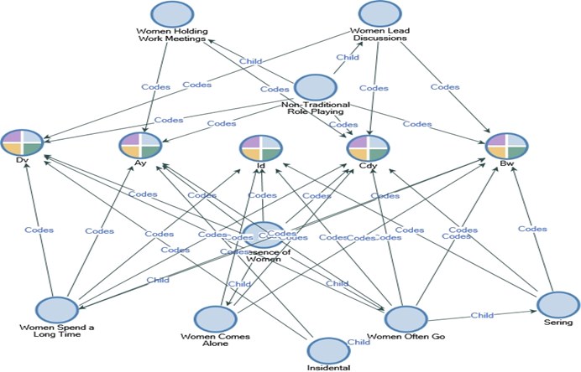
Figure 5. Coding Map of Gender Subversion in the Context of Women's Use of Coffee Shops in West Aceh.

This concept map visualizes how women adopt non-traditional roles in coffee shop spaces, such as leading discussions, working independently, and navigating public presence based on the Qanun. The dots represent key categories and behaviors, while the connecting lines depict the interrelationships between informants and thematic codes such as "Women Come Alone," "Women Lead Discussions," and "Playing No.
These practices align with Scott’s (1985) notion of everyday resistance, yet differ in motivation: rather than opposing religious law, they reinterpret its meaning through discourse and lived practice. Thus, gender contestation here operates through discursive negotiation—women critically engage with Qanun as both a moral guide and a civic concern.n-Traditional Roles.

Synthesis: Dimensions of Gender Participation in Coffee Shops
The thematic synthesis highlights four interrelated dimensions—gender performance, subversion, norm maintenance, and negotiation—that together illustrate the complex and situated nature of women’s participation in Acehnese public life under Qanun-based regulation. These dimensions are not isolated but rather form a continuum of negotiated agency, where women’s everyday practices oscillate between conformity, reinterpretation, and transformation of prevailing moral frameworks.

Table 2. Summary of Gendered Participation Dimensions in Coffee Shops under Qanun Regulation
Dimension | Key Themes | Informant Patterns
Gender Performance | Qanun-related discussions, frequency, duration, leadership in discourse | Cdy, Id lead critical dialogues; Ay problematizes contradictions in Qanun
Gender Subversion | Non-traditional roles, working alone, public voice, informal critique | Cdy, Ay, Dv challenge norms through presence and activity; Bw navigates discreetly
Maintaining Norms | Spatial behavior, modesty, conformity, gradual adaptation of Syariah norms | All informants adhere to social etiquette; Ay and Cdy discuss enforcement gaps
Negotiating Norms | Normalization of presence, participation in discussions and decisions | Uniform across all informants; shift from tolerance to social inclusion

Table 2 reveals a multilayered pattern of female public agency in a region where morality and law intersect. Gender performance—as theorized by Butler (1990)—functions here as an embodied claim to visibility, where women’s actions such as leading discussions or working publicly re-signify space that was once coded as masculine. Through repetitive and visible participation, they reconstitute the performative script of piety and propriety, transforming it from a tool of restriction into a vehicle for expression.
Gender subversion, in turn, corresponds to what Mahmood (2005) calls pious agency: actions that appear compliant yet subtly reconfigure the meaning of obedience. By conducting professional activities, holding meetings, or coming alone to coffee shops, women assert interpretive ownership over public morality without overtly violating Sharia principles. Such practices exemplify the coexistence of piety and autonomy, demonstrating that submission to moral order does not negate agency but provides the very grounds upon which it operates.
Meanwhile, the dimension of norm maintenance reflects Giddens’s (1984) theory of structuration, wherein social actors reproduce dominant norms through practice but also modify them incrementally. The findings indicate that Acehnese women uphold social decorum—through modest dress, time discipline, and spatial self-regulation—yet these same practices carve out room for gradual change. As they internalize and reproduce normative expectations, they simultaneously redefine what constitutes acceptable female presence in public spaces.
Finally, norm negotiation represents the highest stage of adaptation, where female participation transitions from marginal tolerance to normalized inclusion. This aligns with Fraser’s (1990) notion of subaltern counterpublics, where marginalized actors form parallel discursive arenas that eventually influence the mainstream public sphere. In this case, women’s continuous engagement in coffee shops creates micro-publics of deliberation, where conversations about Qanun, gender, and social justice occur within the bounds of cultural legitimacy.
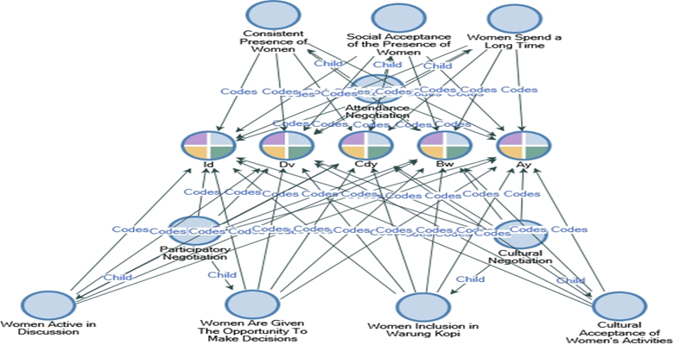
Figure 6. Negotiation of Norms in Women's Public Participation in Coffee Shops Under Qanun Governance.

This matrix visualizes how women negotiate presence, participation, and cultural acceptance through three overlapping layers: spatial visibility, discursive engagement, and moral inclusion. The uniform patterns across informants indicate a gradual normalization of women’s visibility in semi-public spaces traditionally dominated by men.
Figure 6 shows that women's negotiation of norms in West Aceh's public spaces is dynamic and multidimensional. All five informants demonstrated consistent attendance at coffee shops, prolonged attendance, and increasing societal acceptance of their presence. These indicators reflect a broader social shift in how women's visibility in public spaces—historically limited by cultural expectations and the Qanun—is now transitioning into a normalized routine.
In theoretical terms, coffee shops function as hybrid moral–deliberative spaces, where Islamic piety, civic participation, and gendered agency intersect. Women’s actions—such as engaging in discussions about Qanun, leading dialogues, or simply maintaining consistent presence—constitute what Habermas (1989) conceptualizes as communicative action: a process through which public reason and moral understanding are co-constructed. However, unlike Habermas’s secular model, the Acehnese case embodies a faith-based public sphere, where deliberation is morally regulated but socially generative.
This synthesis thus suggests that Acehnese women’s participation in coffee shops is not a binary of compliance versus resistance but a spectrum of negotiated transformation. Through performativity, pious subversion, and norm negotiation, women rearticulate their roles as moral subjects and civic actors simultaneously. The continuity of their engagement marks a discursive shift from private modesty to public religiosity, wherein occupying public space becomes an act of moral citizenship rather than transgression.
Consequently, the study contributes a new understanding of female agency under Islamic governance—one that transcends the dichotomy of oppression and emancipation. Women in West Aceh exemplify how moral conformity and civic deliberation can coexist, forming an emergent model of inclusive Islamic publicness. The findings affirm that public participation, even under restrictive moral frameworks, can serve as a transformative site where gender, faith, and social justice are renegotiated through everyday practice.

CONCLUSION
This research reveals that women's involvement in West Aceh coffee shops reflects three main dynamics. First, women's presence serves as a visibility strategy to assert their existence in a historically male-dominated public sphere. Second, women negotiate social and religious norms through behavioral adaptations, such as choosing visiting times, clothing, and seating positions. Third, coffee shops function as arenas for gender contestation, where women utilize these masculine spaces to build professional networks, discuss issues, and even consolidate social agendas.The implication of these findings is that public sphere in Aceh reflect sharia control and open up possibilities for women to exercise adaptive and subversive everyday agency. Thus, this research strengthens the literature on gender relations, public sphere, and sharia regulation and highlights the importance of viewing coffee shops as a microcosm of women's struggles to negotiate their identities and rights.
This study has several limitations. First, the relatively small number of informants (five) means the findings are contextual and cannot be generalized to all of Aceh. Second, the data were obtained through interviews and observations over a limited period, thus not capturing long-term dynamics. Third, intersectional factors such as social class, marital status, and organizational affiliation have not been explored in depth.
Based on the limitations of this study, future research should consider (1) expanding the sample and study locations, including large cities such as Banda Aceh or Lhokseumawe, to examine variations in women's participation patterns in coffee shops. (2) employing a longitudinal approach to track changes in women's agency over an extended period. (3) integrating intersectional analysis to understand how socioeconomic, religious, and political factors influence women's experiences in public spaces. (4) From a practical perspective, the results of this study can provide input for policymakers so that the Qanun on women's empowerment is not merely normative but truly supports women's equal access to public sphere.

REFERENCES
Abdallah, A. K., & Farhan, A. F. (2023). Breaking Barriers and Empowering Women Leaders to Drive School Improvement (pp. 399–419). https://doi.org/10.4018/978-1-6684-7818-9.ch020
Abdullah, H., Md Zain, F. A., Tajuddin, S. A. F. S. A., Mohammed Foziah, N. H., & Ishak, M. S. I. (2025). Developing employee motivation index: McClelland and Maqasid Shariah. Journal of Islamic Accounting and Business Research, 16(1), 218–244. https://doi.org/10.1108/JIABR-07-2023-0235
Adisa, T. A., Abdulraheem, I., & Isiaka, S. B. (2019). Patriarchal hegemony. Gender in Management: An International Journal, 34(1), 19–33. https://doi.org/10.1108/GM-07-2018-0095
Alam, Md. K., Rahman, M. M., Runy, M. K., Adedeji, B. S., & Hassan, Md. F. (2022). The influences of Shariah governance mechanisms on Islamic banks performance and Shariah compliance quality. Asian Journal of Accounting Research, 7(1), 2–16. https://doi.org/10.1108/AJAR-11-2020-0112
Aziz, D. A. N., Al Khanif, Hartono, M. D., & Marbun, A. A. Y. (2023). Examining Qanun in Aceh from a human rights perspective: status, substance and impact on vulnerable groups and minorities. Ijtihad: Jurnal Wacana Hukum Islam Dan Kemanusiaan, 23(1), 37–56. https://doi.org/10.18326/IJTIHAD.V23I1.37-56
Bahri, S. (2022a). the Role of Women in Implementing Islamic Sharia in the City of Banda Aceh. Fenomena, 21(1), 19–38. https://doi.org/10.35719/fenomena.v21i1.76
Bahri, S. (2022b). The Role Of Women In Implementing Islamic Sharia In The City Of Banda Aceh. Fenomena, 21(1), 19–38. https://doi.org/10.35719/fenomena.v21i1.76
Benstead, L. J. (2021). Conceptualizing and measuring patriarchy: The importance of feminist theory. Mediterranean Politics, 26(2), 234–246. https://doi.org/10.1080/13629395.2020.1729627
Billah, Z. D. (2024). Exploring Women’S Portrayal and Narrative Entanglement in David Lynch’S ‘Blue Velvet’ (1986): Postmodern Cinematic Analysis. ISLLAC : Journal of Intensive Studies on Language, Literature, Art, and Culture, 8(1), 45. https://doi.org/10.17977/um006v8i12024p45-57
Black, A., Esmaeili, H., & Hosen, N. (2013). Modern Perspectives on Islamic Law. Edward Elgar Publishing. https://doi.org/10.4337/9780857934475
Brantner, C., Rodríguez-Amat, J. R., & Belinskaya, Y. (2021). Structures of the Public Sphere: Contested Spaces as Assembled Interfaces. Media and Communication, 9(3), 16–27. https://doi.org/10.17645/mac.v9i3.3932
Brysk, A. (2022). Pandemic patriarchy: The impact of a global health crisis on women’s rights. Journal of Human Rights, 21(3), 283–303. https://doi.org/10.1080/14754835.2022.2071105
Bullock, K. (2018). Pious Fashion: How Muslim Women Dress. American Journal of Islamic Social Sciences, 35(3), 87–90. https://doi.org/10.35632/ajiss.v35i3.486
Bush, E. J., Singh, R. L., & Kooienga, S. (2019). Lived Experiences of a Community: Merging Interpretive Phenomenology and Community-Based Participatory Research. International Journal of Qualitative Methods, 18. https://doi.org/10.1177/1609406919875891
Butler, J. (1990). Gender Trouble: Feminism and the Subversion of Identity. Routledge.
Carel, H. (2011). Phenomenology and Its Application in Medicine. Theoretical Medicine and Bioethics, 32(1), 33–46. https://doi.org/10.1007/s11017-010-9161-x
Cohen, D., Jasper, K., Zhao, A., Moalla, K. T., Nwuke, K., Nesamoney, S., & Darmstadt, G. L. (2024). Gender norms in a context of legal pluralism: Impacts on the health of women and girls in Ethiopia. Global Public Health, 19(1). https://doi.org/10.1080/17441692.2024.2326016
de Boer, M., & Zeiler, K. (2024). Qualitative Critical Phenomenology. Phenomenology and the Cognitive Sciences. https://doi.org/10.1007/s11097-024-10034-7
Ferry, N. (2025). Where is the patriarchy?: A review and research agenda for the concept of patriarchy in management and organization studies. Gender, Work & Organization, 32(1), 302–329. https://doi.org/10.1111/gwao.13145
Firouzabadi, S. A., Shadman, S. S., Rezasoltani, P., & Vedadhir, A. (2024). Painful Dream of Motherhood: A Hermeneutic Phenomenological Study of Married Women with Ectopic Pregnancy in the Islamic Republic of Iran. Journal of Religion and Health, 63(3), 2327–2343. https://doi.org/10.1007/s10943-023-01936-y
Fransen, R. (2023). Can P/CVE be salvaged? Lessons and questions from gendered practice. Journal of the British Academy, 11(S1), 157–176. https://doi.org/10.5871/jba/011s1.157
Fraser, N. (1990). Rethinking The Public Sphere: A Contribution To The Critique Of Actually Existing Democracy. Social Text, 56–80.
Habermas, J. (1991). The Structural Transformation Of The Public Sphere: An Inquiry Into A Category Of Bourgeois Society (T. Burger, Ed.). MIT Press.
Hadaiyatullah, S. S., Fikri, A., Dharmayani, D., Karini, E., & Ismail, H. (2024). Rekontekstualisasi Fikih Keluarga di Era Modern: Studi Perbandingan Indonesia, Tunisia, dan Turki. Moderasi : Journal of Islamic Studies, 4(2), 140–163. https://doi.org/10.54471/moderasi.v4i2.70
Inayatillah. (2023). Acehnese Women in Public Spaces: Theirmovement and Political Participation. Jurnal Ilmiah Peuradeun, 11(1), 117–136. https://doi.org/10.26811/peuradeun.v11i1.823
Insani, N., Ibrahim, Z. S., Karimullah, S. S., Gönan, Y., & Sulastri, S. (2024). Empowering Muslim Women: Bridging Islamic Law and Human Rights with Islamic Economics. De Jure: Jurnal Hukum Dan Syar’iah, 16(1), 88–117. https://doi.org/10.18860/j-fsh.v16i1.26159
Jalil, A. T., Shanshool, M. T., Dilfy, S. H., Saleh, M. M., & Suleiman, A. A. (2022). Hematological and serological parameters for detection of COVID-19. Journal of microbiology, biotechnology and food sciences, 11(4), e4229-e4229.
Johnson, P. M. (2019). Waria Genres: Identity, Embodiment, and the Performance of Gendered Belonging in Contemporary Indonesia (Doctoral dissertation, UC Berkeley).
Jiménez-Moya, G., Carvacho, H., Álvarez, B., Contreras, C., & González, R. (2022). Is Support for Feminism Enough for Change? How Sexism and Gender Stereotypes Might Hinder Gender Justice. Frontiers in Psychology, 13. https://doi.org/10.3389/fpsyg.2022.912941
Kennedy, J., & Pek, S. (2023). Mini-publics, student participation, and universities’ deliberative capacity. Studies in Higher Education, 48(1), 63–82. https://doi.org/10.1080/03075079.2022.2111551
Kivijärvi, M., & Katila, S. (2022). Becoming a Gamer: Performative Construction of Gendered Gamer Identities. Games and Culture, 17(3), 461–481. https://doi.org/10.1177/15554120211042260
Latue, P. C., Manakane, S. E., & Rakuasa, H. (2023). Policy Review and Regional Development in Disaster Mitigation (Case Study: 2004 Aceh Tsunami and 2011 Tōhoku Tsunami). International Journal of Multidisciplinary Approach Research and Science, 1(03), 288–301. https://doi.org/10.59653/ijmars.v1i03.165
Lindkvist, C. (2024). Gendered mobility strategies and challenges to sustainable travel—patriarchal norms controlling women’s everyday transportation. Frontiers in Sustainable Cities, 6. https://doi.org/10.3389/frsc.2024.1367238
Lofaro, R. J., & Miller, H. T. (2021). Narrative Politics in Policy Discourse: The Debate Over Safe Injection Sites in Philadelphia, Pennsylvania. Contemporary Drug Problems, 48(1), 75–95. https://doi.org/10.1177/0091450921993821
Lopes Cardozo, M. T. A., & Srimulyani, E. (2021a). Analysing the spectrum of female education leaders’ agency in Islamic boarding schools in post-conflict Aceh, Indonesia. Gender and Education, 33(7), 847–863. https://doi.org/10.1080/09540253.2018.1544361
Lopes Cardozo, M. T. A., & Srimulyani, E. (2021b). Analysing the Spectrum of Female Education Leaders’ Agency in Islamic Boarding Schools in Post-Conflict Aceh, Indonesia. Gender and Education, 33(7), 847–863. https://doi.org/10.1080/09540253.2018.1544361
Madsen, S. R., Townsend, A., & Scribner, R. T. (2020). Strategies That Male Allies Use to Advance Women in the Workplace. The Journal of Men’s Studies, 28(3), 239–259. https://doi.org/10.1177/1060826519883239
Mahmood, S. (2005). Politics of piety: The Islamic Revival and the Feminist Subject. Princeton University Press.
Manan, A., & Salasiyah, C. I. (2022). Implementation of Islamic Sharia Laws in East Aceh: The Acehnese Perspectives. Journal of Contemporary Islam and Muslim Societies, 6(2), 149.
Mashhour, A. (2005). Islamic Law and Gender Equality: Could There be a Common Ground?: A Study of Divorce and Polygamy in Sharia Law and Contemporary Legislation in Tunisia and Egypt. Human Rights Quarterly, 27(2), 562–596. https://doi.org/10.1353/hrq.2005.0022
Maspul, K. A. (2023). Cultural Exchange and Resilience: Shaping Coffee Consumption in Saudi Arabia's Coffee Shops. J-CEKI: Jurnal Cendekia Ilmiah, 2(6), 693-707.
Meeussen, L., Van Laar, C., & Van Grootel, S. (2020). How to Foster Male Engagement in Traditionally Female Communal Roles and Occupations: Insights from Research on Gender Norms and Precarious Manhood. Social Issues and Policy Review, 14(1), 297–328. https://doi.org/10.1111/sipr.12060
Munira, W., Akhyar, M., & Djono, D. (2018). Women`s Leadership and Gender Equality in Aceh: A Socio-historical Perspective. International Journal of Multicultural and Multireligious Understanding, 5(4), 79. https://doi.org/10.18415/ijmmu.v5i4.187
Novita, D., Sar’an, M., Ahmad Ridwansah, A., Suharyono, S., & Ardiansyah, H. (2025). Family Conflict Disclosure on Social Media in Islamic Law: Islah as a Reconciliation Mechanism. Al-Istinbath: Jurnal Hukum Islam, 10(1), 443–458. https://doi.org/10.29240/jhi.v10i1.12658
Offermann, L. R., & Foley, K. (2020). Is There a Female Leadership Advantage? In Oxford Research Encyclopedia of Business and Management. Oxford University Press. https://doi.org/10.1093/acrefore/9780190224851.013.61
Pieczka, M., & Escobar, O. (2013). Dialogue and science: Innovation in policy-making and the discourse of public engagement in the UK. Science and Public Policy, 40(1), 113–126. https://doi.org/10.1093/scipol/scs073
Qiu, R. (2023). Traditional gender roles and patriarchal values: Critical personal narratives of a woman from the Chaoshan region in China. New Directions for Adult and Continuing Education, 2023(180), 51–63. https://doi.org/10.1002/ace.20511
Rauchfleisch, A., Vogler, D., & Eisenegger, M. (2021). Public Sphere in Crisis Mode: How the COVID-19 Pandemic Influenced Public Discourse and User Behaviour in the Swiss Twitter-sphere. Javnost - The Public, 28(2), 129–148. https://doi.org/10.1080/13183222.2021.1923622
Sabbah-Karkabi, M. (2024). The diverging gender inequality across households: The case of Palestinian-Arab families in Israel. Current Sociology, 72(3), 519–540. https://doi.org/10.1177/00113921221141471
Shadiqin, S. I., & Srimulyani, E. (2022). The Contested Authorities: Institution and Agency in the Enforcement of Sharia Law in Aceh, Indonesia. Journal of Contemporary Islam and Muslim Societies, 5(2), 198.
Shah, R. (2024). Challenges of Doing Gender Research as a Male Researcher in Pakistan: Reflections From Online and In-Person Fieldwork. International Journal of Qualitative Methods, 23. https://doi.org/10.1177/16094069241230021
Standal, K., & Winther, T. (2016a). Empowerment Through Energy? Impact of Electricity on Care Work Practices and Gender Relations. Forum for Development Studies, 43(1), 27–45. https://doi.org/10.1080/08039410.2015.1134642
Standal, K., & Winther, T. (2016b). Empowerment Through Energy? Impact of Electricity on Care Work Practices and Gender Relations. Forum for Development Studies, 43(1), 27–45. https://doi.org/10.1080/08039410.2015.1134642
Sufri, S., Dwirahmadi, F., Phung, D., & Rutherford, S. (2020). Enhancing community engagement in disaster early warning system in Aceh, Indonesia: opportunities and challenges. Natural Hazards, 103(3), 2691–2709. https://doi.org/10.1007/s11069-020-04098-2
Sufyan, M. S., Ansor, M., Mawardi, M., & Ismail, S. (2022). Subaltern Agency and Economic Resilience of Marginalized Community in Aceh. Share: Jurnal Ekonomi Dan Keuangan Islam, 11(1), 20. https://doi.org/10.22373/share.v11i1.10362
Tamunomiegbam, A., & Arinze, D. (2024). From Tradition to Transformation: Evolving Gender Norms in Contemporary Africa. American Journal of Public Policy and Administration, 9(3), 1–36. https://doi.org/10.47672/ajppa.2003
Wadud, A. (2013). Qur’an and Woman: Rereading the Sacred Text From a Woman’s Perspective (2nd ed.). (2nd ed). Oxford University Press.
Wijanarko, M. F., & Madaniyyah, F. (2025). Analisis Performativitas Gender Representasi Wanita Independen Modern. Iuris Studia: Jurnal Kajian Hukum, 6(2), 388-396.
Wood, H. J. (2019). Gender inequality: The problem of harmful, patriarchal, traditional and cultural gender practices in the church. HTS Teologiese Studies / Theological Studies, 75(1). https://doi.org/10.4102/hts.v75i1.5177
Xu, Z., Chang, J., Cheng, F., Liu, X., Yao, T., Hu, K., & Sun, J. (2024). Examining the impact of the built environment on multidimensional urban vitality: Using milk tea shops and coffee shops as new indicators of urban vitality. Buildings, 14(11), 3517.
Yildirim, T. M., Kocapınar, G., & Ecevit, Y. A. (2021). Status Incongruity and Backlash against Female Legislators: How Legislative Speechmaking Benefits Men, but Harms Women. Political Research Quarterly, 74(1), 35–45. https://doi.org/10.1177/1065912919861443
Zulkifli, Z., Rahman, A., Martina, M., Mumtiza, R., & Risma, M. (2022). Social construction of law enforcement for sexual violence against women in Aceh Utara. Jurnal Civics: Media Kajian Kewarganegaraan, 19(2), 224–234. https://doi.org/10.21831/jc.v19i2.52631

